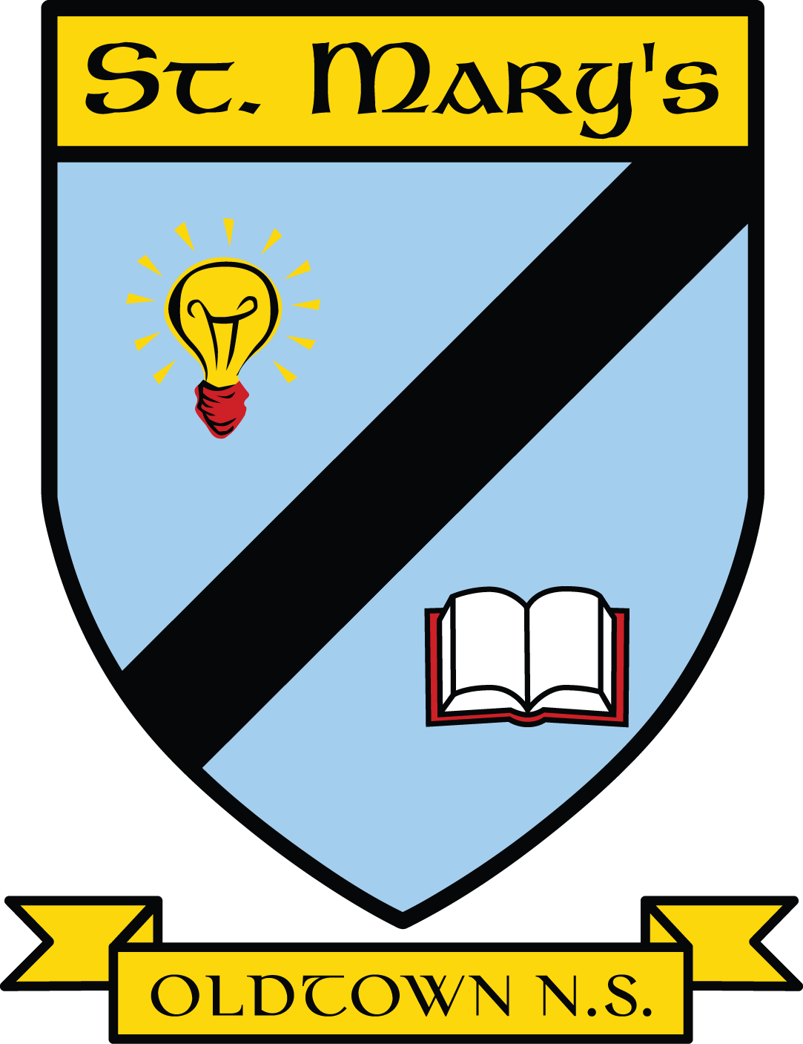St. Mary’s National School,

Oldtown,

Co. Dublin.

Phone: 01-8432060

Email: [oldtownns@gmail.com](mailto:oldtownns@gmail.com)

Roll No. 17263D

Annual Admission Notice 2024

Enrolment forms are now available for the 2025/26 academic year on our website [www.oldtownns.ie](http://www.oldtownns.ie) . Alternatively you can contact the school office at [oldtownns@gmail.com](mailto:oldtownns@gmail.com).

Applications are accepted from 1st October 2024 until 31st December 2024. Applicants will be notified of the decision by mid-January 2025. Successful applicants should confirm acceptance of the offer no later than 31st January 2025. The offer of a place may be withdrawn if the applicant does not accept the offer of admission within the above time frame.

|  |  |
| --- | --- |
| 2024/25 School Year | |
| Amount of places accepted in mainstream Junior Infants | 6 |
| Amount of places available in our autism class | 3 |
| Amount of children on a waiting list for our autism class | 4 |

|  |  |
| --- | --- |
| 2025/26 School Year | |
| Places available in mainstream Junior Infants | 20 |
| Places available in autism class | 3 |

St. Mary’s National School, Oldtown,Co. Dublin.

Phone: 01-8432060Email: [oldtownns@gmail.com](mailto:oldtownns@gmail.com)

Roll No. 17263D